19.03.2020
ОДБ.03 Иностранный язык
Группа ПКД19-1
Преподаватель: Куцаева К.П./Полякова М.В.
Срок сдачи: до 23.03.2020
(выполненные работы отправлять на электронную почту – kermen080985@mail.ru)
Переписать правило в тетрадь
Выполнить задания письменно
Тема: Условные предложения 1,2 и 3 типа
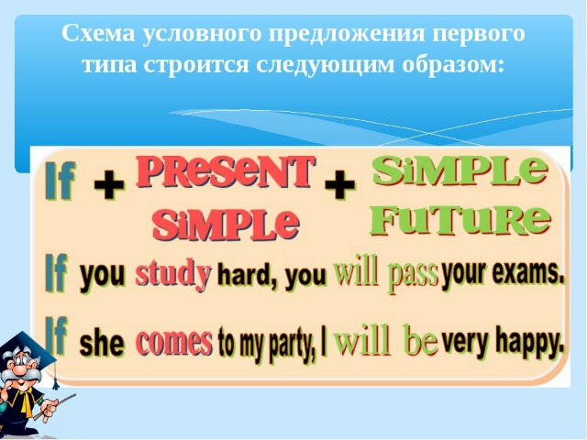
- If you put the ice cubes into very hot water,they (crack).
- If he (win),he (get) 100,000 dollars;if he (come) in second,he (get) 50,ooo.
- If he (want) more money,he (have) to do more work.
- If you (not take) this book to the library tomorrow,you (have) to pay a fine.
- If you (like),I (get) you a job in this company.
- If the weather (be) good,we (go) to the country.
- I (tell) him the whole truth if I (know) it.
- If he (invite) me,I (go) to his party.
- If it (freeze) tonight,the roads (be) very slippery tomorrow.
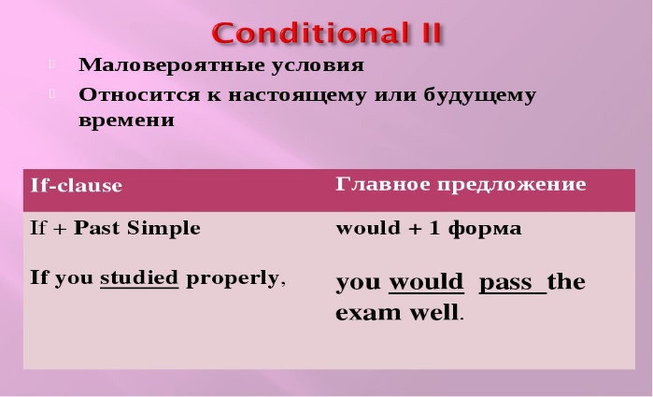
1. If I had a spare ticket,I … take you to the cinema.
a) would b) will
2. John suggested that I should … for another job.
a) look b) have looked
3. If she … you,she would be able to advise you.
a) had been b) were
4. We were afraid lest he should … too early.
a) have come b) come
5. She would buy a new fur coat if her husband … enough money.
a) would give b) gave
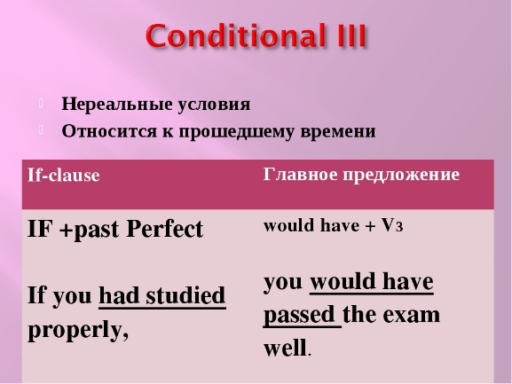

- If there (be) any snow round there,we (go) skiing.
- If my friend (know) my address,he (find) my house.
- If I (receive) your letter,I (answer) it.
- If he (give up) smoking,he (look) better.
- If we ( invite) them,they (come) to our party.
- If I (know) they need me,I (come) at once.
- If we (learn) the truth,she (be) very angry.

